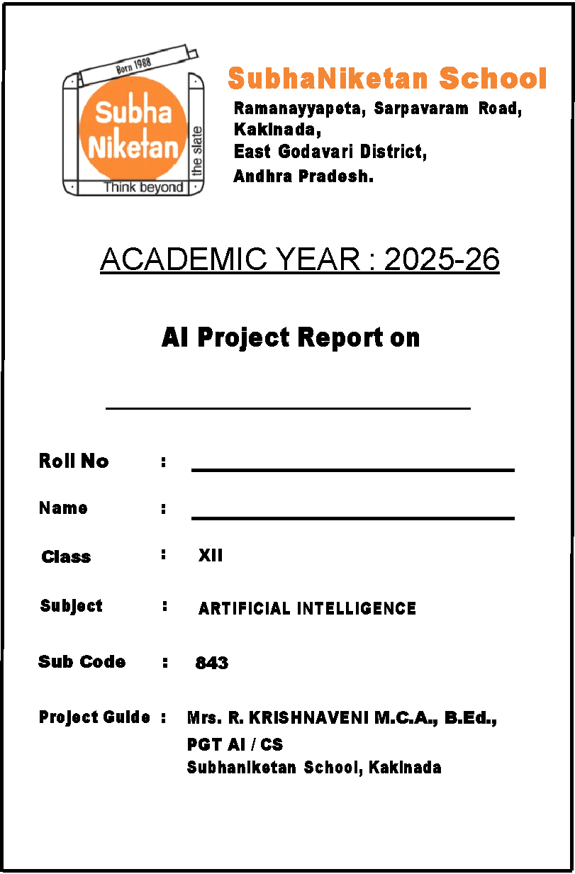**Project Documentation**

**PROJECT NAME:** HEART DISEASE PREDICTION

**SCHOOL NAME:** SUBHA NIKETAN SCHOOL, KAKINADA, AP

**YEAR/CLASS:** 2025-26 / XII

**TEACHER NAME:** Mrs. R. KRISHNAVENI

**TEACHER EMAIL:** [rkv05121978@gmail.com](mailto:rkv05121978@gmail.com)

**TEAM MEMBER NAMES AND GRADES:**

1. Hima Varshini XII MEA
2. Tashu Bohra XII MEA
3. Siri Sri Vraja XII BEA
4. Nitya Akshaya XII BEA
5. Tanmayee XII MPC

# Introduction

In this project, we focused on addressing an important **healthcare issue**—the early detection of **heart disease risk**. Heart disease is a leading cause of health problems worldwide, and many patients are diagnosed late because symptoms can be unclear. With the help of Artificial Intelligence (AI), we can analyze health-related data and predict whether a person may be at risk, thereby supporting timely medical consultation.

# Team Roles

* 1. **Who is in your team and what are their roles?**

| Role | Role description | Team Member Name |
| --- | --- | --- |
| **Project leader** | Schedules the task among the team member, Ensures the task is completed on time, Resolves doubts (if any), and one source of contact | Hima Varshini |
| **Data expert** | Decides upon the data required, type of data for training the model, collects the data, ensures the type of data, and its authenticity. | Tanmayee |
| **Information researcher** | Collects questions from the end users which needs to be answered, look for the answers for those questions and then prepare a report which will be passed to the project leader | Nitya |
| **Designer** | Will create the design and the flow of how to go about making the solution for the problem statement. | Siri |
| **Prototype builder/coder Tester** | Works to build the model, train it followed by testing the efficiency and accuracy of the model | Tashu |
| **Tester** | * Works with users to tests the prototype * Gets feedback from users * Creates an action plan on what needs to be fixed and prioritizes requests for future improvements | **All Team members** |
| **Video Producer** | * Films the activities of the team and edits these into a presentation for submission | **Hima Varshini** |

# Project plan

| **Phase** | **Task** | **Planned start date** | **Planned end date** | **Planned duration (hours, minutes)** | **Actual start date** | **Actual end date** | **Actual duration (hours, minutes)** | **Who is responsible** | **Notes/Remarks** |
| --- | --- | --- | --- | --- | --- | --- | --- | --- | --- |
| **Preparing for the project** | Coursework, readings | **10/07/2025** | **10/07/2025** | **1 hour** | **10/07/2025** | **10/07/2025** | 1 hour | **All Team Members** | Each member is responsible |
| **Forming the team** | Getting to know the people in the team | **11/07/2025** | **11/07/2025** | **1 hour** | **11/07/2025** | **11/07/2025** | 1 hour | **All Team Members** |  |
| **Defining the problem**  **(SDG Aligned)** | Background reading | **14/07/2025** | **14/07/2025** | **1 Hour** | **14/07/2025** | **14/07/2025** | 1 hour | **All Team Members** | Collaborative work |
| Research issues in our community | **15/07/2025** | **15/07/2025** | **0.5**  **Hours** | **15/07/2025** | **15/07/2025** | 1.5 hours | **All Team Members** |  |
| **Understanding the users** | Identify users | **16/07/2025** | **16/07/2025** | **30 Mins** | **16/07/2025** | **16/07/2025** | **30 Mins** | **All Team Members** |  |
| Meeting with users to observe them | **17/07/2025** | **17/07/2025** | **30 Mins** | **17/07/2025** | **17/07/2025** | **30 Mins** | **All Team Members** |  |
| Interview with user (1) | **18/07/2025** | **18/07/2025** | **15 Mins** | **18/07/2025** | **18/07/2025** | **15 Mins** | **Nitya** |  |
| Interview with user (2) | **19/07/2025** | **19/07/2025** | **15 Mins** | **19/07/2025** | **19/07/2025** | **15 mins** | **Hima Varshini** |  |
| **Brainstorm the solution** | Generate ideas | **21/07/2025** | **21/07/2025** | **1.5**  **Hours** | **21/07/2025** | **21/07/2025** | **1.5**  **Hours** | **All Team Members** |  |
|  | Vote on best idea | **22/07/2025** | **22/07/2025** | **0.5 Hour** | **22/07/2025** | **22/07/2025** | **1 Hour** | **All Team Members** |  |

| **Design solution** | Document the steps that the users will do | **23/07/2025** | **23/07/2025** | **1 Hour** | **23/07/2025** | **23/07/2025** | **1 Hour** | **All Team Members** |  |
| --- | --- | --- | --- | --- | --- | --- | --- | --- | --- |
| **Collecting and preparing data** | Analysing data requirements | **24/07/2025** | **24/07/2025** | **30 Mins** | **24/07/2025** | **24/07/2025** | **30 Mins** | **Nitya and Siri** |  |
| **Building Prototyping** | Developing the AI Model | **25/07/2025** | **25/07/2025** | **1 Hour** | **25/07/2025** | **25/07/2025** | **1 Hour** | **Tashu** |  |
| **Prototyping Testing** | Team meeting to discuss testing plan | **28/07/2025** | **28/07/2025** | **20 mins** | **28/07/2025** | **28/07/2025** | **30 mins** | **All Team Members** | **Designing** |
| Test your model and keep training with more data until you think your model is accurate | **29/07/2025** | **29/07/2025** | **30 Mins** | **29/07/2025** | **29/07/2025** | **30 Mins** | **Tashu** | **Code testing** |
| Conduct testing with users | **30/07/2025** | **30/07/2025** | **30 Mins** | **30/07/2025** | **30/07/2025** | **45 Mins** | **All Team Members** |  |
| **Reflection on Project** | Reflect on the project with your team | **31/07/2025** | **31/07/2025** | **1 hour** | **31/07/2025** | **31/07/2025** | **1 hour** | **All Team Members** |  |
| **Creating the video** | Team meeting to discuss video creation | **04/08/2025** | **04/08/2025** | **15 Mins** | **04/08/2025** | **04/08/2025** | **15 mins** | **Hima Varshini** |  |
|  | Write your script | **05/08/2025** | **05/08/2025** | **1 hour** | **05/08/2025** | **05/08/2025** | **30 Mins** | **Tanmayee and Tashu** |  |
|  | Film your video | **06/08/2025** | **06/08/2025** | **1 hour** | **06/08/2025** | **06/08/2025** | **30 Mins** | **Siri** |  |
|  | Edit your video | **07/08/2025** | **07/08/2025** | **30 Mins** | **07/08/2025** | **07/08/2025** | **30 Mins** | **Hima Varshini** |  |

# 2.3 Communications Plan:



# 2.4 Team meeting minutes (create one for each meeting held)



**.**









| **Date of meeting: 28/07/2025**  **Who attended: Hima Varshini, Tashu, Nitya, Tanmayee, Siri**  **Who wasn’t able to attend:** Nil  **Purpose of meeting:**  Team meeting to discuss the testing plan  **Items discussed:**   1. Checking the performance of the program. 2. Classifying the dataset into has heart disease or not.   **Things to do (what, by whom, by when)**   1. Testing 2. Each team member will do the work according to their roles assigned. |
| --- |





**Date of meeting: 30/07/2025**

**Who attended: Hima Varshini, Tashu, Nitya, Tanmayee, Siri**

**Who wasn’t able to attend:** Nil

**Purpose of meeting:** Team meeting to discuss video creation

**Items discussed:**

**1.** Roles forscripting

**2.** Choosing the tool

**3.** Filming

**Things to do (what, by whom, by when)**

**1.** Creating video

**2.** By each team member

**3.** Same Day

# 3. Problem Definition

* 1. **List important local issues faced by your school or community**



* 1. **Which issues matter to you and why?**



* 1. **Which issue will you focus on?**



**3.4 Team’s problem statement.**



# 4. Understand Your Users

* 1. **Who are the users and how are they affected by the problem?**



* 1. **What have you actually observed about the users and how the problem affects them?**



* 1. **Record your interview questions here as well as responses from users.**



Interviewer: Can you share your thoughts on the heart disease detection model you've been using?

User: Absolutely, I'd be happy to. Firstly, I want to express my sincere appreciation for this incredible tool. It's truly revolutionized the way we approach early detection of heart disease.

Interviewer: That's great to hear! What specifically stands out to you about the model?

User: The accuracy and efficiency are truly remarkable. Knowing there's a reliable system in place brings immense peace of mind. It saves time and enhances the chances of early intervention and treatment, potentially saving countless lives.

Interviewer: How do you find the user interface and presentation of results?

User: The user interface is intuitive and user-friendly, accessible to both medical professionals and patients. The transparent presentation of results and explanations instills confidence in the findings, fostering trust in the system.

Interviewer: Would you trust an AI system to help diagnose heart disease? Why or why not?

User: I would consider it if the system is validated with clinical data and can explain its decisions clearly. Trust comes with transparency and proven accuracy.

Interviewer: What patient data do you think is most important for AI to analyze for heart disease prediction?

User: Age, blood pressure, cholesterol levels, ECG readings, family history, and symptoms like chest pain or shortness of breath are critical.

Interviewer: It sounds like you're genuinely impressed with the model. Any final thoughts?

User: Absolutely. I'm genuinely grateful for the dedication and expertise that went into developing this model. It represents a significant advancement in medical technology and serves as a beacon of hope for those affected by heart disease. Thank you for making a tangible difference in the fight against this disease and for providing a ray of hope for a brighter, healthier future.

* 1. **Empathy Map**

Map what the users say, think, do and feel about the problem in this table

| **What our users are saying**   * **Are the tests authentic?** * **Are they reliable?** * **Where do I go for a timely and accurate diagnosis?** | **What our users thinking**   * **How time consuming will it be** * **How fast can I get my results** * **Is the result normal or is there some abnormality** * **Prescribed medications that are to be taken** |
| --- | --- |
| **What our users are doing**   * **Not taking timely action** * **Procrastinating on the checkup** * **Not consulting a specialist** | **How our users feel**   * **CONFUSED** * **ANXIOUS** * **STRESSED** |

* 1. **What are the usual steps that users currently take related to the problem and where are the difficulties?**



**Usual steps that users currently take and difficulties faced have been illustrated using a hypothetical scenario.**

**A patient visits a doctor at a hospital**

Patient: - Doctor, I need to get a checkup

Doctor: - Please get an appointment at the reception desk Patient gets an appointment after 4 days and gets a CT-Scan

Doctor: - Mr./Mrs. Patient your test results have not come normal and we suspect a **cardiac tumor** may be present.

Patient: - Doctor are you sure that it’s related to heart how can you be certain?

Doctor: - You will have to wait for some days before we can actually come at a result till then take care of your health and have a healthy diet.

Few days go by and the patient gets eager to know the results and then contacts the doctor.

Patient: - Hello Doctor what do my reports state.

Doctor: - It is certain that there is a **cardiac tumor** and the abnormality can be observed in the image.

Patient: - What should I do now? What treatment should I undergo?

Doctor: - We might also recommend medications to control blood pressure, cholesterol, or other contributing factors. In some cases, procedures like angioplasty or surgery might be necessary to restore blood flow or repair heart function. I’ll work with you to develop a treatment plan tailored to your specific condition, and we’ll monitor your progress closely to adjust the plan as needed.

The important thing is to stay proactive—following advice and attending regular check-ups can significantly improve your heart health and quality of life.”

Patient: - Okay doctor we will start with the treatment, what are the forms and other formalities that need to be taken care of.

Doctor: - Please show this note at the reception and the receptionist will provide you the required details.

* 1. **Refine your problem statement.**



# 5. Brainstorming

* 1. **Ideas**

How might you use the power of AI/machine learning to solve the users’ problem by increasing their knowledge or improving their skills?

| AI Idea #1 | **Personalized Learning Platforms**   * AI-powered apps that tailor educational content on heart health based on user’s existing knowledge and learning pace. * Interactive modules with quizzes and real-time feedback. |
| --- | --- |
| AI Idea #2 | **Symptom Checker & Risk Assessment Tools**   * ML models analyse user inputs (symptoms, lifestyle, medical history) to estimate heart disease risk and suggest next steps. * Helps users understand their condition and when to seek professional care. |
| AI Idea #3 | **Virtual Health Coaches**   * AI chatbots that provide daily tips on diet, exercise, and medication adherence, personalized to the user’s health status. * Motivates behaviour change through reminders and encouragement. |
| AI Idea #4 | **Simulations & Visualizations**   * Use ML-generated 3D heart models to demonstrate how lifestyle choices or medications impact heart function over time. * Makes complex concepts easy to understand. |
| AI Idea #5 | **Language and Accessibility Adaptation**   * ML-powered translation and simplification tools to make heart health education accessible across languages and literacy levels. |

High

Low

* 1. **Priority Grid**

Evaluate your AI ideas based on value to users and ease of creation and implementation.

| **High value to users, easy to create**  - Symptom Checker & Risk Assessment Tool - Personalized Content Recommendation - AI Chatbot for Basic Health Coaching | **High value to users, hard to create**  -Explainable AI Models for Risk Prediction - Continuous Monitoring with Wearables & Real-Time Feedback - Skill Training Simulations for Healthcare Professionals |
| --- | --- |
| **Low value to users, easy to create**  - Simple FAQ Chatbots - Basic Static Educational Modules | **Low value to users, hard to create**  -Advanced 3D Heart Simulations (Complex Visualizations) - Community Matching based on Health Profiles |

Easy Hard

EASE OF DEVELOPMENT

* 1. **Based on the priority grid, which AI solution is the best fit for your users and for your team to create and implement?**

Briefly summarize the idea for your solution in a few sentences and be sure to identify the tool that you will use.



# Design your solution

* 1. **What are the steps that users will now do using your AI solution to address the problem?**



# 7. Identify and Collect Data

* 1. **What type of data will you need to train your AI solution?**



# 8. Prototype

* 1. **Which AI tool(s) will you use to build your prototype?**



* 1. **Which AI tool(s) will you use to build your solution?**



**8.3 What decisions or outputs will your tool generate and what further action needs to be taken after a decision is made?**



# 9. Testing

* 1. **Who are the users who tested the prototype?**



* 1. **List your observations of your users as they tested your solution.**



**9.3 Complete the user feedback grid**

| What works  The precision and accuracy rate calculations. | What needs to change  The data which is not present in the predefined dataset is to be added. |
| --- | --- |
| Questions? | Ideas |
|  |  |
| How much time is taken to provide the results? |  |
|  | More work required on making the predictions |
| How accurate are the results? | accurate |

* 1. **Refining the prototype: Based on user testing, what needs to be acted on now so that the prototype can be used?**



* 1. **What improvements can be made later?**



# 10. Team collaboration

**10.1 How did you actively work with others in your team and with stakeholders?**



# 11. Individual learning reflection

**11.1. Team Reflections**

A good way to identify what you have learned is to ask yourself what surprised you during the project. List the things that surprised you and any other thoughts you might have on issues in your local community.

**Team member name: Hima Varshini .V**

**Team member name: Tashu, Siri.P**

**Team member name: Nitya.P, Tanmayee.P** 

# 12. Links

URL of the Project:

**Video Link:** <https://github.com/snskkd2025/Heart_Disease_Model>

**Video Link:** [**https://github.com/snskkd2025/Heart_Disease_Model/blob/main/Vdo_Heart_Disease_Prediction.mp4**](https://github.com/snskkd2025/Heart_Disease_Model/blob/main/Vdo_Heart_Disease_Prediction.mp4)